Git Progresss File

1. Cd git folderPath
2. Git clone[url]

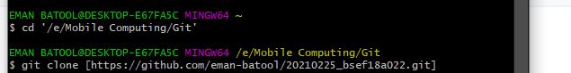

* Make txt file in Git => repository folder inside Git
* Cd repository .eg 20210225
* ls/dir
* For hidden files ls -a/dir
* Open.git or open file name

